Dessert Pizza  Chocolate Chip  Smores  Taffy Apple  Fruit Pizza  Peanutty Brownie Pizza  Chocolate Macaroon Pizza  $18 each  Donuts  Apple Cider Donuts  6 for $8  Pumpkin Spice Donuts  6 for $8  Granola  $5/lb.  Chocolate Chip Granola  Pecan Pie Granola  Apple Pie Granola | About me  Hi! My name is Lisa Younger and I am a licensed food operator in Unionville, CT since October 2018 using the Cottage Food Law. While I do not have a traditional store front, we follow all strict guidelines set by the state of Connecticut.  All of the delectable items sold have been tested and tried to perfection and will be treasured forever. We help busy people make baking easy for them. Within 48-hour notice you will have fresh, delicious baked goods for you. No sitting on the shelf for days! Perfect place to call for birthdays, weddings, church events, anniversary, fundraisers, and business meetings! Affordable and easy to pick up!  How the business works:  I receive orders, prepare the order, and we meet up at a public place such as downtown Unionville. Please allow 48-hour notice from time of pickup. If the order is over $25, I do require ½ of the total before the pickup time to secure the order. | Delectable Creations  Unionville, CT  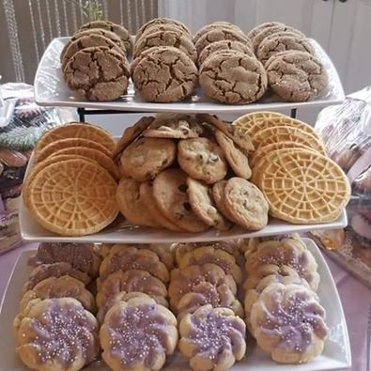  860-712-6607  ljyoungr@yahoo.com  Facebook Page #delectablecreationsunionvilleCT
Cookies  2 DOZEN OF SAME KIND OF COOKIE $14  pARTY trAY:  2 DOZEN OF 4 KINDS OF COOKIES (8 DOZEN) $50  Chocolate Chip  Peanut Butter Oatmeal Chocolate Chip  Pecan Tassies  Reese’s Peanut Butter Cup  Peanut Butter Kiss Cookies  Gingersnaps  Chocolate Snowflake  Snickerdoodles  Italian Frosted Chocolate Spice  Italian Frosted Egg Biscuit  Sparkling Butter Toffee  Sugar Cookie  Coconut Macaroons dipped in chocolate  M and M Cookies  Double Chocolate Chip  Italian Pizzelles (Choose Anise, Vanilla, Lemon)  Oatmeal Raisin  Lemon Spritz  Reese’s Chocolate Peanut Butter Chip | Muffins  Blueberry Muffins (1 dozen) $12  Corn Muffins (1 dozen) $10  Double Chocolate (1 dozen) $12  Lemon Poppy Seed (1 dozen) $10  Cakes/Cupcakes  Perfectly Chocolate Cake (9 inch) with Chocolate or Vanilla Frosting $15  Vanilla Cake (9 inch) with Chocolate or Vanilla Frosting $15  Red Velvet Cake (9 inch) with Cream Cheese Frosting $15  Cupcakes (1 dozen) of any flavor above $14 | Gluten Free  Blueberry Muffins (9) $10  Cranberry Orange (9) $10  Chocolate Chip Cookies (2 dozen) $16  bREADS  Banana Bread $7  Pumpkin Bread $7  Apple Bread $7  Zucchini Bread $7  French Bread Loaf $7  Pies  Apple $13  Blueberry $14  Peach $15  Pecan $18  Dutch Apple $15

